Autoclave Processing Research Paper.
Name
October 29th, 2020

Autoclave processing occurs via the composite manufacturing technique whereby the thermoplastic matrix and the fibrous reinforcement material are both laid in the desired pattern on a tool and spot welded to ensure that all stacked plies are intact and their relative movement towards each other is avoided. The other part of the assembly is bagged in a vacuum and kept inside the autoclave. Intermediate thermoplastic composite forms from prepregs and hybrid yarns offer a good process ability in this method. The major products manufactured via this technique are the composites of aerospace. The reason behind this is due to the high-quality materials used, that is versatile to fiber orientation, material qualities produced, and the high volume of fiber fraction.
The typical lay-up and autoclave processing steps refer to all the processes that occur from the first step of manufacturing, which is from the freezer to the last step which is the inspection of the autoclaves and packaging. The prepregging is the first step which involves reinforcement by dipping saturated fiberglass, carbon, or aramid fiber into the liquid resin. The prepreg is taken out of the refrigerator and stored for a while at room temperature for thawing to take place. The prepreg is however laid on the table and cut into the desired orientation. The prepreg is then laid on a mold surface. Air entrapped between the prepreg sheets is removed consequently.
Bagging vacuum arrangements are made via application of a release bleeder, film, bagging materials, and barrier film. This happens after the application of the prepreg sheets. The other part of the assembly is then placed inside of an autoclave, if the structure is large, then a trolley is used. All cycle cure data are fed into a computerized machine and adhered to. The cooling process then follows after which the vacuum is removed and the other part was taken out. Resin or the thermosetting matrix are some of the reinforcement materials that are commonly utilized in the process. Careful considerations of change in the viscosity of the matrix are other considerations to take care of to ensure that the reinforcement is successfully achieved. The fibers play a greater role in ensuring that desired strength is achieved. It is the matrix that binds together the fibers and ensures that it uniformly distributes the load. Matrix prevents surface damage to the fibers and by providing ductility.
The cure cycles of the composite manufacturing techniques are designed according to the pressure, time, and temperature. The cure cycles however depend on the utilized materials. The curing process depends on pressure, temperature, and time. In the thermal portion, 350 farads are required in the thermoset. The thermal portion is usually composed of two holds and two isothermal holds. In the first isothermal hold and ramp, temperature ranges between 240-280 farads. This allows volatiles to escape while the resin flows. In the other isothermal hold, a temperature of between 340-370 farads is maintained for the epoxy resin systems. Resin is then held in this cure temperature for between 4 to 6 hours. This time allows the process of crosslinking to occur and get completed.
However, high pressures are also essential and are commonly used in the processing of autoclaves. This is important in that it suppresses the formation of void and also provides compaction of ply. Specifically, 100 psig pressure is usually used in the autoclave processing. Fiber content, amount of the bleeder, and configuration of the laminate are the factors that affect the translation of autoclave pressure to the used resin. Specialty equipment required for this process is the high temperature and pressure sources.
There other equipment which is also made using the composite curing process which is the process used for the manufacturing of autoclaves. This process has been intensely utilized by the ASC Process Systems which is the world’s leading and biggest manufacturer of autoclaves and other equipment. Many of this equipment are composites, aerospace ovens, vulcanizing, nuclear, and also in glass manufacturing industries. The world’s well-recognized control system the CPC is also manufactured in the ASC process systems manufacturers. The company also ensures that they provide its workers with a safe working environment due to the high temperature and pressure processes which occur during the manufacturing process. It offers a healthy working environment and a friendly environment required in any working environment.
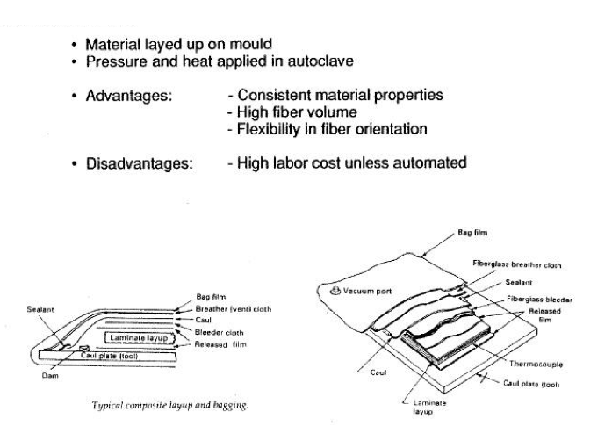

https://xirtue.net/composite-manufacturing-process
Some benefits have been associated with the use of the composite autoclave processing technique. This process, which is the autoclave curing process makes use of very high pressures and high temperatures as well. This allows the use of highly performing heat-cured epoxy and unidirectional carbon fibers. Also, during the processing of thermoset laminate, a low viscosity during the temperature processing ensures that evaporation occurs efficiently. The flow of the resin also utilizes the newton force. The long time it takes for the flow to occur is also significant to the system in ensuring that the quality of the final products is achieved. Some of the disadvantages associated with this method include; the cost of the prepregs is high. Also, storage at warmer temperatures reduces the shelf life. The process also requires high temperature and pressure extremities.
The composite autoclave technique is also used in the processing of CPC controls and controls apart from the autoclaves. However, composites for aerospace applications are one of the products manufactured via this technique due to the versatility orientation of the fiber, high quality of the produced materials, and also the high volume fraction of fiber used in the process. Materials used during this process entirely depends on the desired product being made. In the case of an autoclave, resin, mold, bleeder pack, cork dam, and a prepreg pack are used. However, prepregs of epoxy glass fiber, epoxy carbon fiber are applied in the processing of aerospace and computer applications.
The cost incurred in this process differs depending on the raw materials and conditions used during the manufacturing process. For instance, continuous molding of autoclaves of high quality can be achieved, in spite that the process is expensive and also slow. The cost of the prepregs is also high. Adding up the cost of the prepregs to that of the fabric the cost becomes more. Some of the complications associated with the process are the inability of some manufacturers to achieve the high temperatures which are needed for the manufacturing and curing process. Also, since the process demands a lot of capital, this can act as a complication when a manufacturer cannot meet the processing requirements.
Complications of bridging across the mold corners can also occur. This happens when the normal pressure to be transmitted to the laminate stops in plane plies from slipping and the laminate happens not to be attached to the corner zone mold. Consolidating material at the geometric change can become a challenge. A combination of pressure and vacuum which acts on the assembly applies pressure uniformly over the surface leading to a high-quality laminate which is usually made up of 60-70% volume fiber fractions and a high dimensional control level. This leads to the high quality of laminates which requires high capital investments. The normal fiber volume fractions which can be achieved stably is 50%, which the CPC manufacturing company has been using in the lamination process of autoclaves.
When purchasing an autoclave, it is good to consider the maintenance costs of the autoclave. However, it is important to consider the costs of spare parts in any case your machine needs replacements. The utility cost of the machine. Autoclaves prices can however vary depending on their size and intended purpose. Some of the autoclaves may cost $100, 000. There are also training costs that one has to undergo to get familiarized properly with the machine by the manufacturers.

References
Grunenfelder, L. K., Dills, A., Centea, T., & Nutt, S. (2017). Effect of prepreg format on defect control in out-of-autoclave processing. Composites Part A: Applied Science and Manufacturing, 93, 88-99.
Centea, T., Grunenfelder, L. K., & Nutt, S. R. (2015). A review of out-of-autoclave prepregs–Material properties, process phenomena, and manufacturing considerations. Composites Part A: Applied Science and Manufacturing, 70, 132-154.

